Popular Vector Databases
1. Pinecone
Type: Fully managed cloud-native vector database
Best For: Enterprise-grade applications needing scalability and reliability
Pros:
- Fully managed (no infrastructure setup)
- High scalability (billions of vectors)
- Fast query performance
- Hybrid search (semantic + keyword)
- Strong integration with ML frameworks
Cons:
- Premium pricing
- Limited customization
- No on-premises deployment
Ideal Use Cases:
- Virtual assistants
- Recommendation engines
- Customer-facing AI apps with strict SLAs
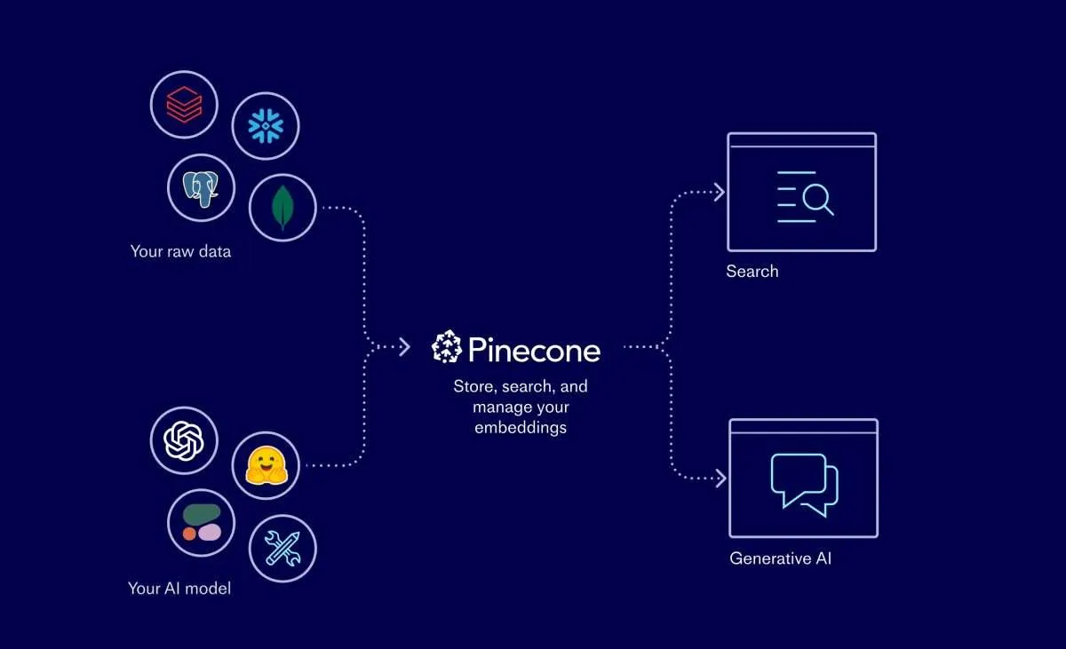
2. Weaviate
Type: Open-source vector database with knowledge graph capabilities
Best For: Semantic search with structured relationships
Pros:
- GraphQL API for flexible queries
- Combines vector search with knowledge graphs
- Supports multi-modal data (text, images)
- Self-hosted or managed cloud options
Cons:
- Steeper learning curve
- Resource-intensive for large datasets
- Requires schema design
Ideal Use Cases:
- Knowledge bases
- Content management systems
- Semantic search engines
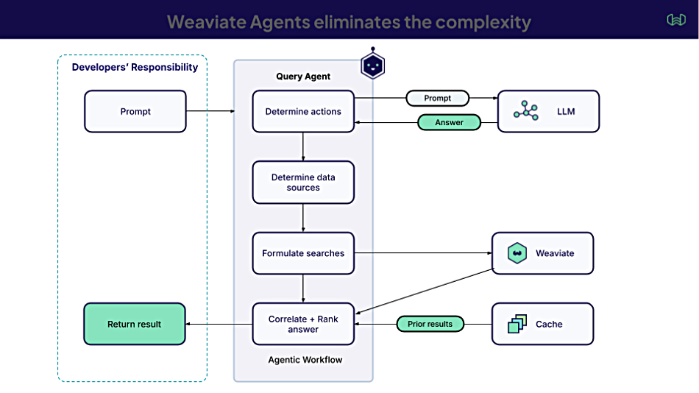

3. FAISS (Facebook AI Similarity Search)
Type: Open-source library for similarity search
Best For: Research and high-performance local deployments
Pros:
- Blazing fast performance (especially with GPU)
- Highly customizable indexing algorithms
- Free and open-source
- Ideal for computer vision and ML tasks
Cons:
- Not a full database (requires external storage)
- No built-in metadata filtering
- Manual setup and integration needed
Ideal Use Cases:
- Research projects
- Offline tools and demos
- Custom AI pipelines needing speed and control
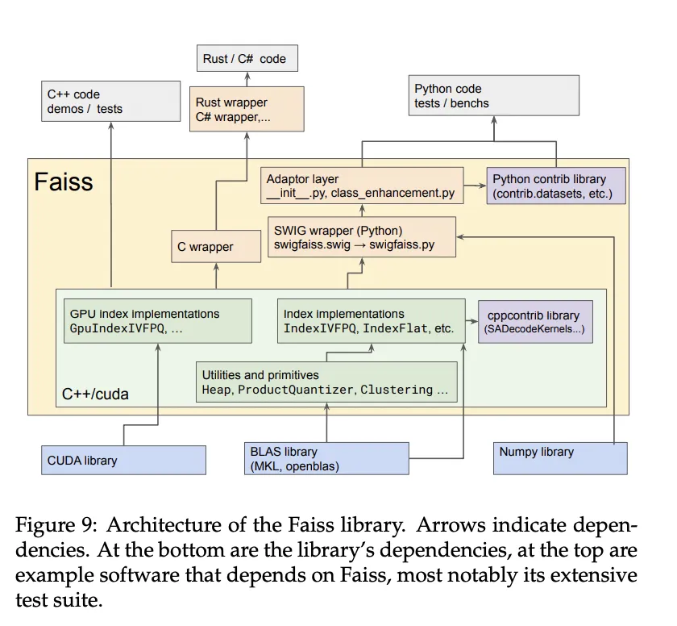

4. Azure AI Search
Type: Managed search service with vector capabilities (part of Microsoft Azure ecosystem)
Best For: Enterprises already using Azure services
Pros:
- Integrated with Azure ecosystem (e.g., Cognitive Search, OpenAI)
- Supports hybrid search (text + vector)
- Scalable and secure
- Built-in support for semantic search and RAG
Cons:
- Less flexible than dedicated vector DBs
- Pricing can be complex
- Limited indexing algorithm customization
Ideal Use Cases:
- Enterprise search portals
- AI-powered document retrieval
- Applications leveraging Azure OpenAI or Cognitive Services
